# Logarithm

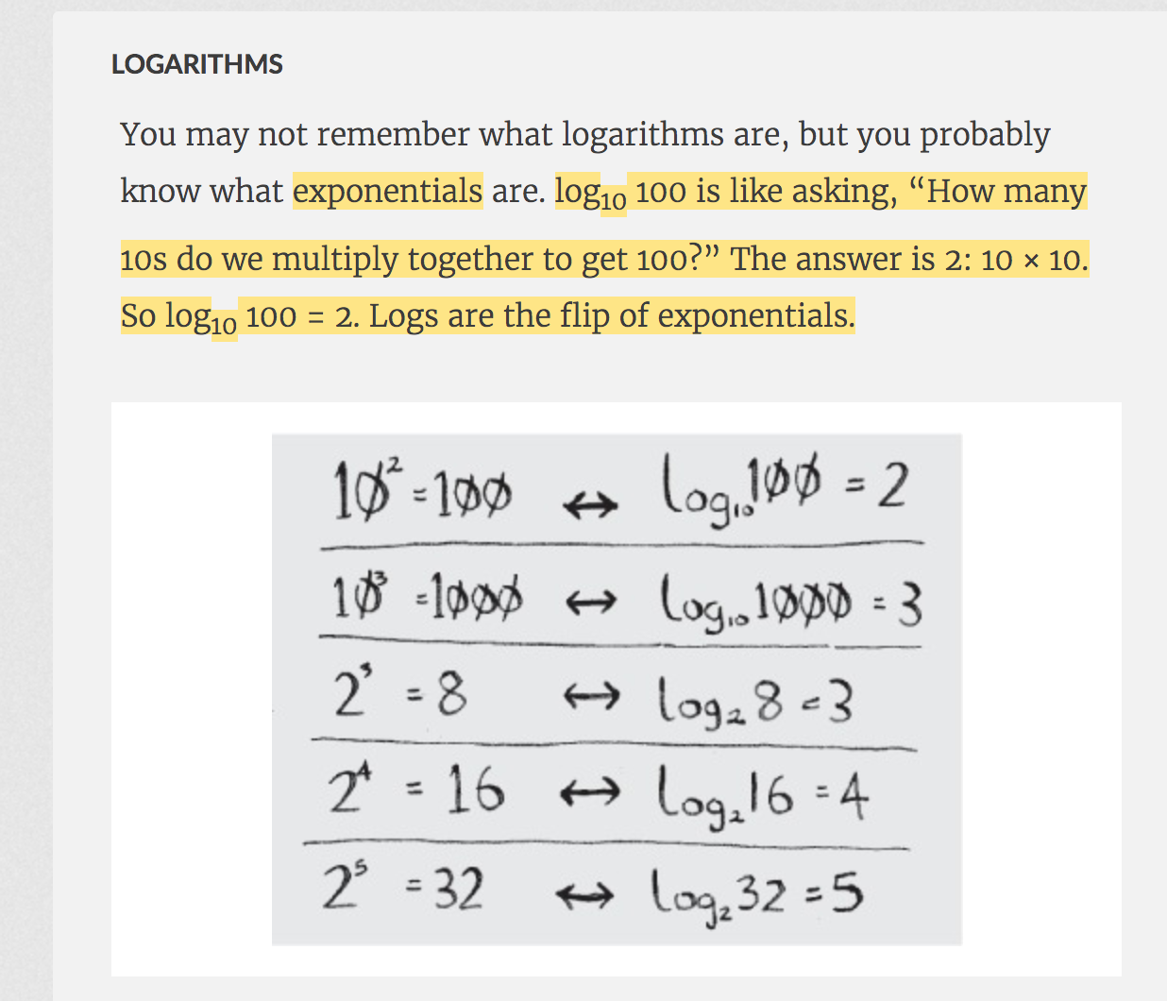

# Big O Notation

Big O doesn’t tell you the speed in seconds. Big O notation lets you compare the number of operations.

# 

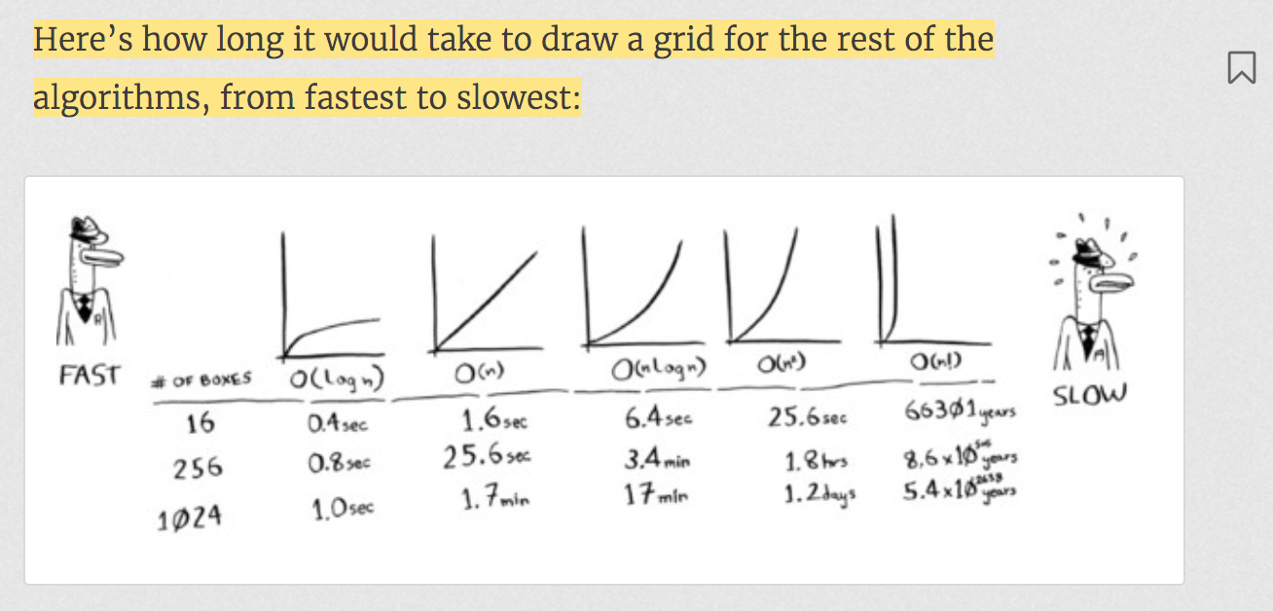

# Binary Search

* Binary Search works only on Sorted Array.
* It doesn’t work on linked list because it has to access element by index.
* It takes O(log n).

*o  
 /\  
 o o  
 /\ /\  
 o o o o  
 /\  
o o*In binary search, to search an element, you divide an array into two and then you keep searching on its one side.  
This is like binary search tree. It takes max O(log n) to search an element in bst.

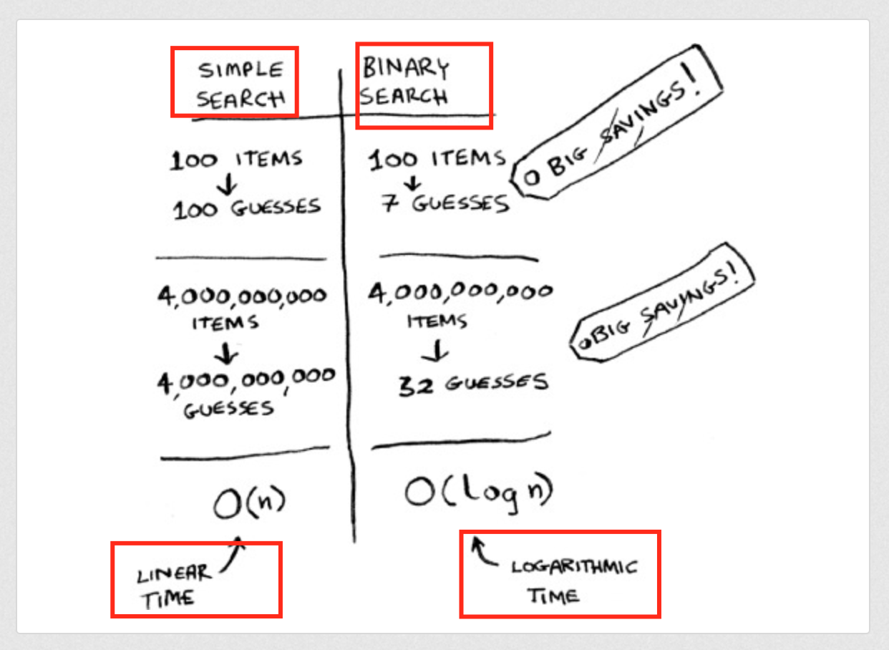

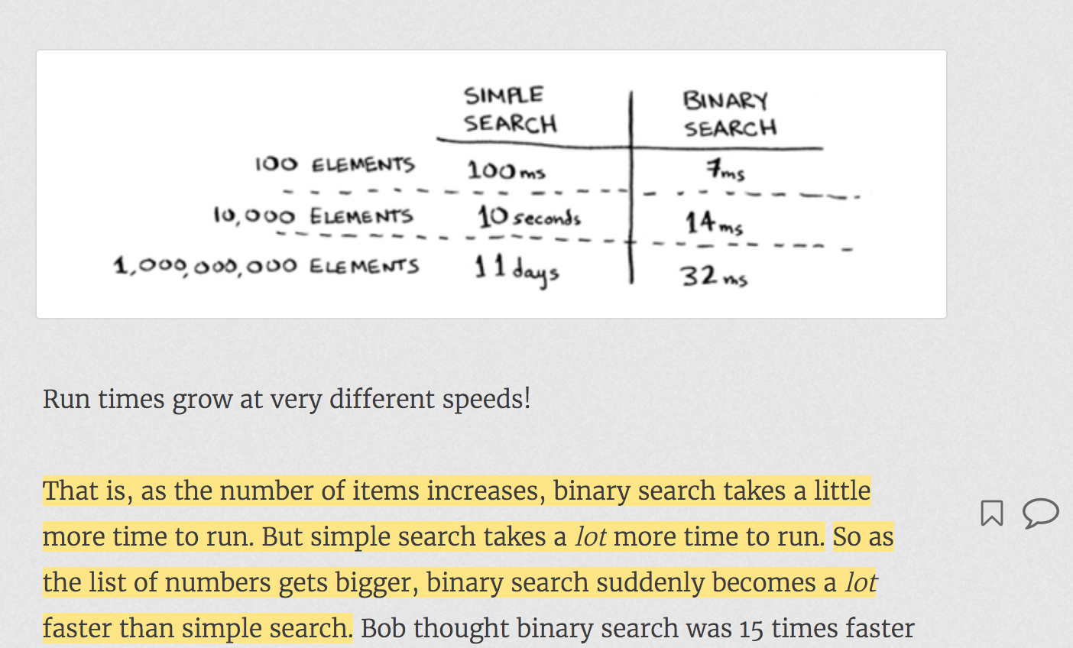

## When you need to work with array:

binarySearchAlgorithmRecursive(array, 0, array.**length** - 1, elementToSearch)

* Always pass start and end element position in array to recursive method.
* One of the Exit condition will be if(start<end)…
* When you need to convert recursive method into iterative method, extra passed parameters to recursive method becomes local variables and after that that you need to add a while loop for reoccurring code.

# Arrays and List

# 

 If you’re out of space and need to move to a new spot in memory every time, adding a new item will be really slow.

With linked lists, your items can be anywhere in memory.

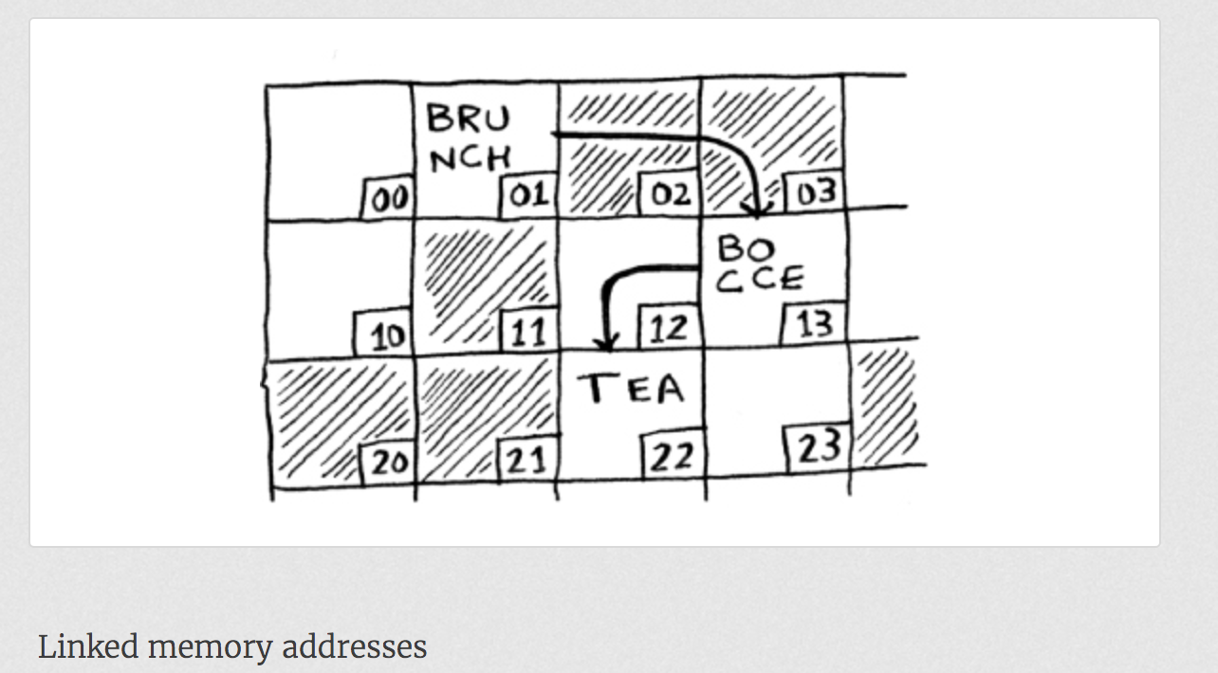

Adding an item to a linked list is easy: you stick it anywhere in memory and store the address with the previous item.

Suppose you want to read the last item in a linked list. You can’t just read it, because you don’t know what address it’s at. Instead, you have to go to item #1 to get the address foritem #2. Then you have to go to item #2 to get the address for item #3.

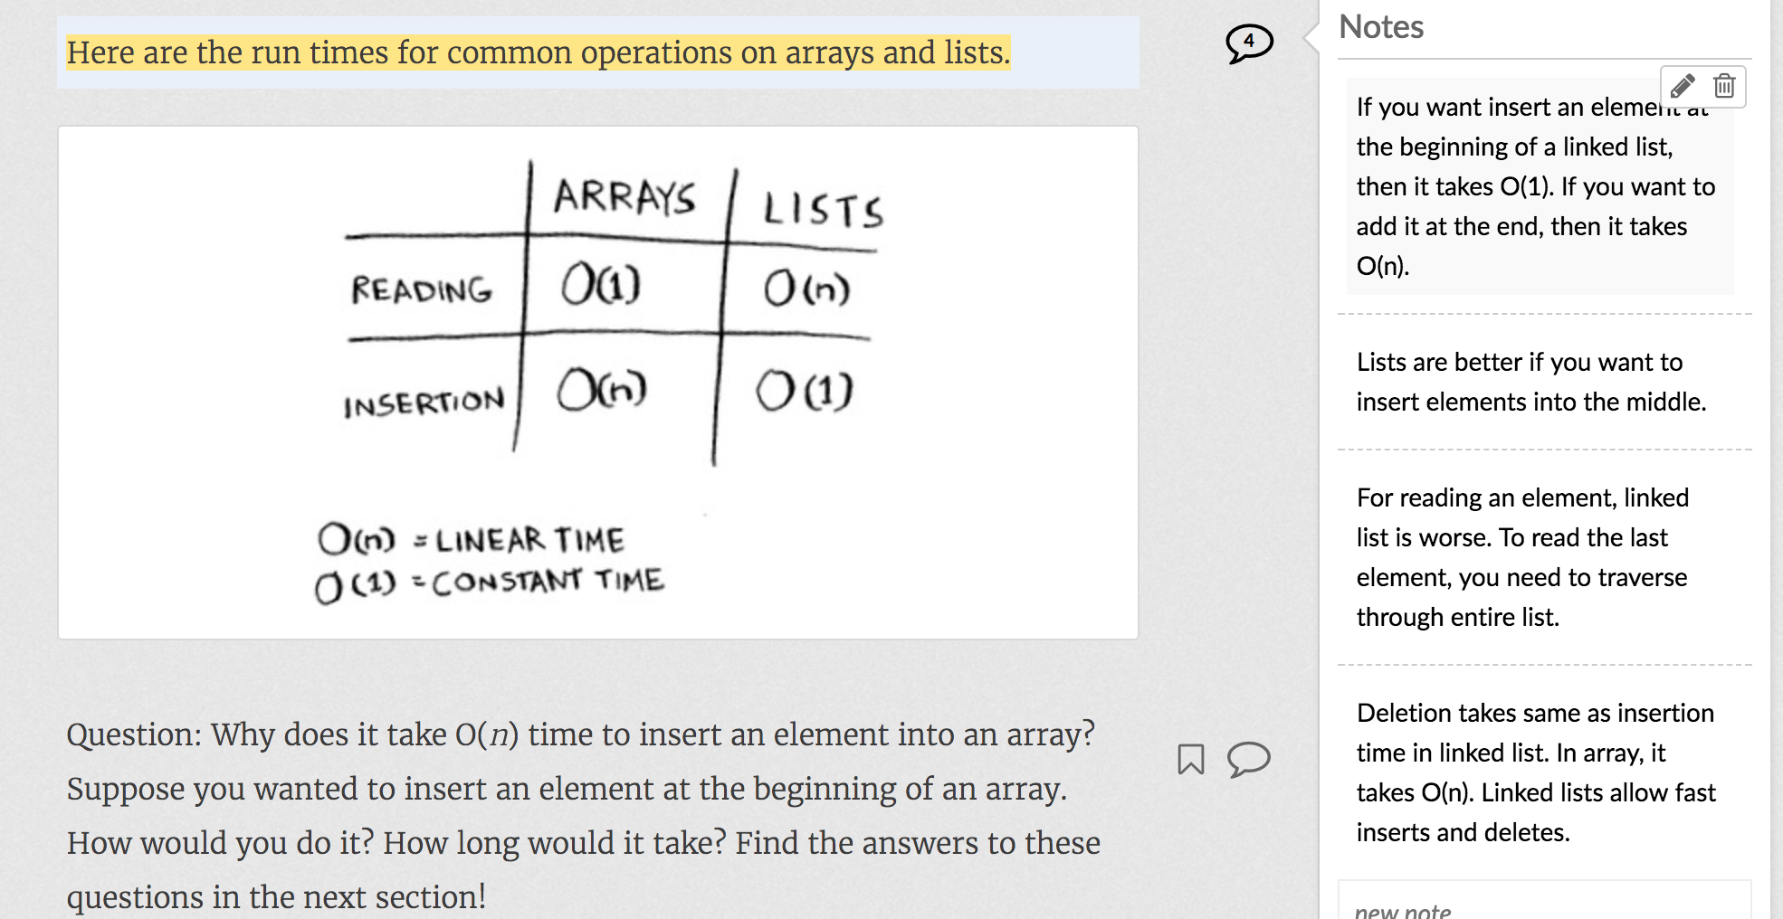

Lists are better if you want to insert elements into the middle.

# 

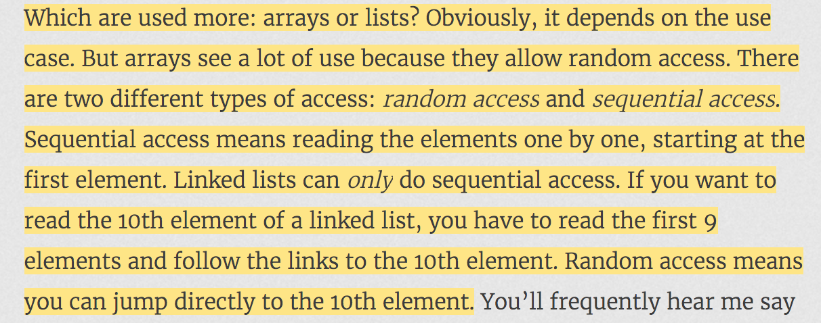

# Bubble Sort and Selection Sort

Selection sort is a stepping stone to quicksort, which I’ll cover in the next chapter. Quicksort is an important algorithm, and it will be easier to understand if you know one sorting algorithm already.

Bubble Sort:

You need to compare each element of an array with all other elements.

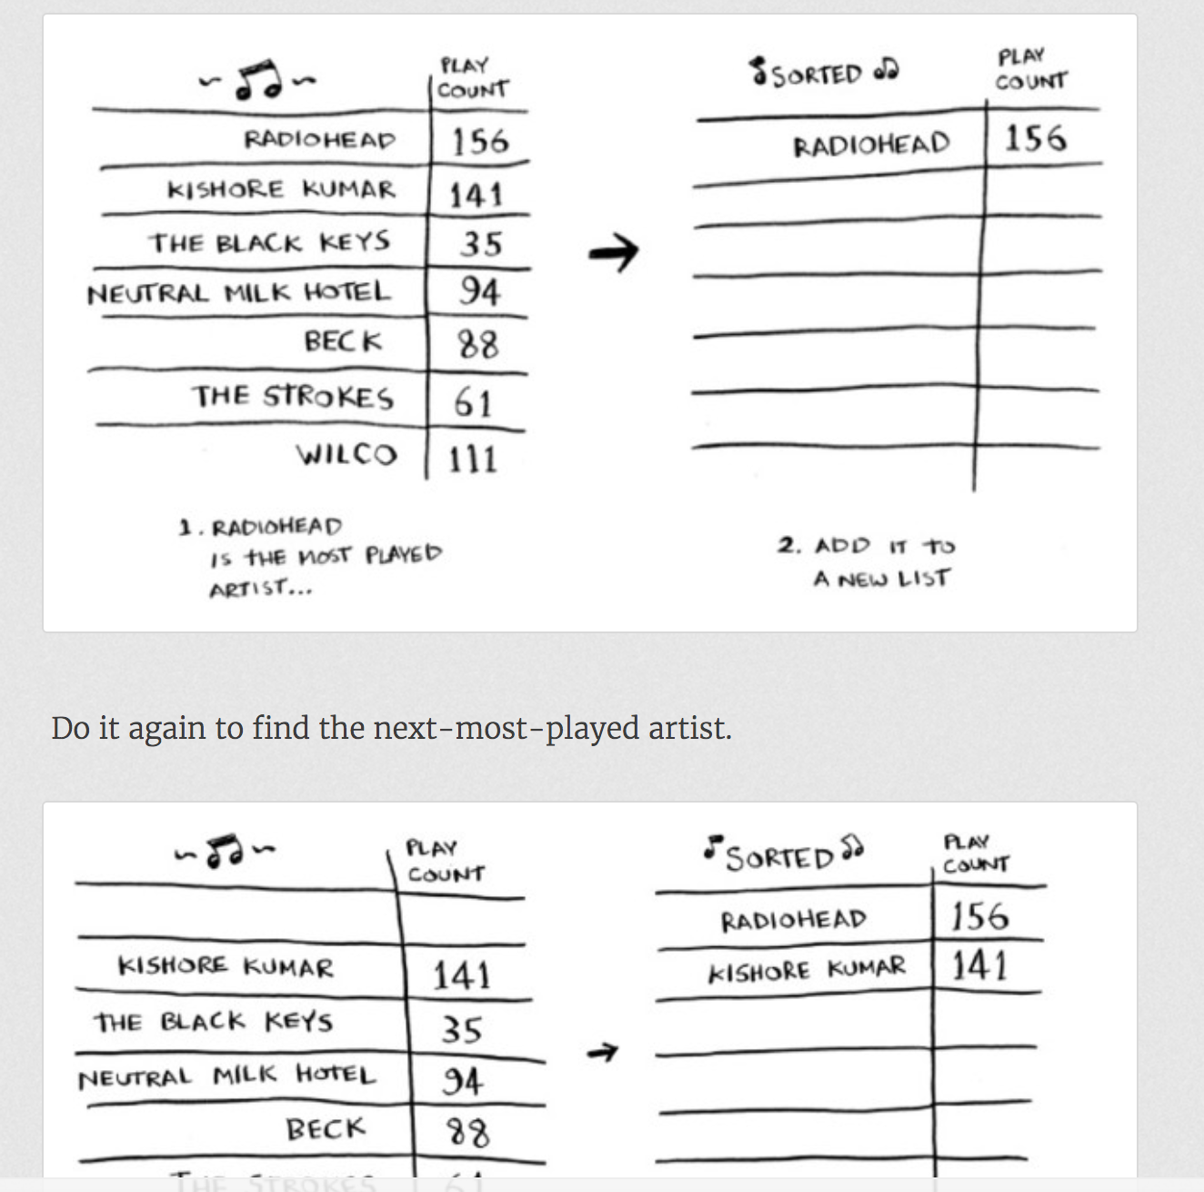

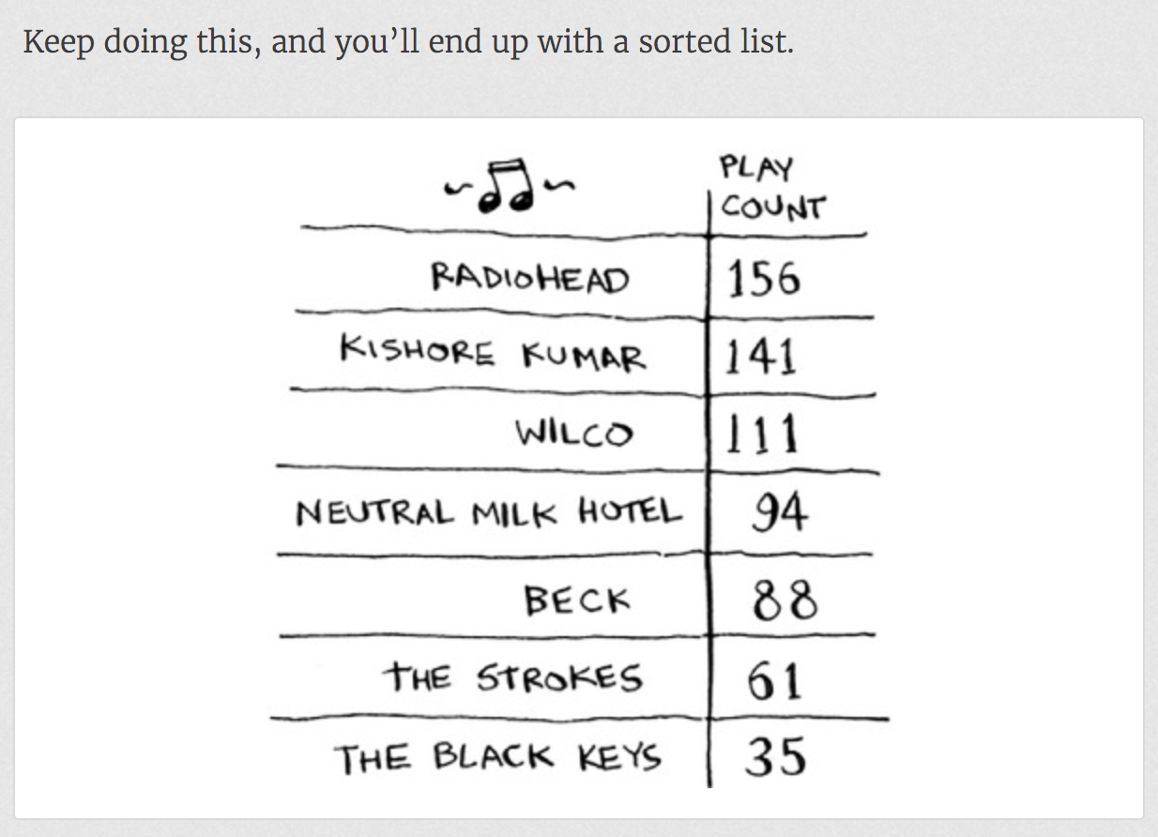

To find the artist with the highest play count, you have to check each item in the list. This takes O(*n*) time, as you just saw. So you have an operation that takes O(*n*) time, and you have to do that *n* times:

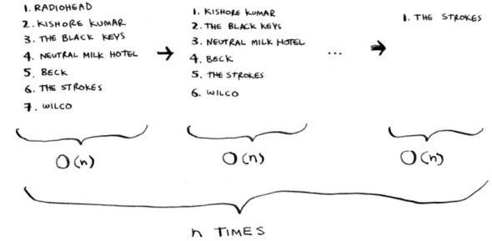

This takes O(*n* × *n*) time or O(*n*2) time.

Bubble Sort compares first element with other elements and if first element > other element, then exchanges(swaps) them.

**Unlike to Bubble Sort, Selection Sort does not swap the elements after every comparison.**  
It **keeps min=i**. Compares each element of array with a[min]. if a[min]>a[other index], then min=other index.  
At the end, it swaps elements of a[i] and a[other index].

But both Bubble Sort and Selection Sort takes O(n2) operations.